## Module (Bootstrap Basic & Advanced) – 6

**1. What are the advantages of Bootstrap?**

**ans.**

The first thing is that now days people use mobiles, laptops, tabs, personal computers. If we have to reach our website to all people, we should spread our business more and more. The website should be such that everyone can read and view the content of your website well. So now we will not make different designs for different devices because may be a new Mobile Screen Ratio may come tomorrow, or if a new laptop screen size is launched, then our website will not work well on it. So to avoid all this mess Bootstrap is there. In which you have to create a website just once, then whatever the screen viewer opens the website on any screen, the UI (User Interface) of the website will be shown well. And people create and sell templates from bootstrap which people use in WordPress, Joomla, Drupal etc.

1. **Saving time**

This is the biggest advantage of Bootstrap that using it increases the development speed and ets the work done in a very short time. On the contrary, if you want to create a responsive design without bootstrap by yourself, then you have a lot of time in it. May take

1. **Easy to use**

If you have basic knowledge of HTML and CSS, then you can easily use Bootstrap.

1. **Responsive Design**

Through bootstrap you can easily create responsive design. If your website is responsive then it adjusts itself according to the screen size in any platform or device like desktop, laptop, mobile etc.

1. **Cross Browser Compatible**

Bootstrap is designed in such a way that our web-page will look the same in almost all modern browsers like Firefox, Chrome, Internet Explorer, Opera etc.

1. **Open Source**

The best thing about it is that you can use it for free.

1. **Customization**

Bootstrap is easy to customize, customize means that if you do not want all the features of bootstrap, you can only use a few features. On Bootstrap’s website give you a lot of options (Nav bar, Table, Form, Button, Model, Dropdown, Badges, etc.) Let you tick what you want, remove the tick from what you don’t want and download and use it. Do it All the CSF classes are already created in Bootstrap, we just have to use those classes in our website and very easily and in a very short time. We create a beautiful website in this way, Bootstrap reduces the time taken in our website development.

**2. What is a Bootstrap Container, and how does it work?**

**ans.**

Bootstrap Containers are the most basic layout element in Bootstrap. Bootstrap Containers are very essential and basic building blocks of bootstrap that wrap a page’s content. It’s responsible for setting and aligning content within it according to viewport or given device. Containers are defined within the container class (.container). In other words, we can say that containers are established the width for the layout to give the content. Elements and content are added within the container.

**3. What are the default Bootstrap text settings?**

**ans.**

**example:**

<https://github.com/chandaniacharya/Assignments/blob/main/BS%20assignment%20practicles/container.html>

**4. What do you know about the Bootstrap Grid System?**

**ans.**

**Grid System:** Bootstrap Grid System allows up to 12 columns across the page. You can use each of them individually or merge them together for wider columns. You can use all combinations of values summing up to 12. You can use 12 columns each of width 1, or use 4 columns each of width 3 or any other combination.[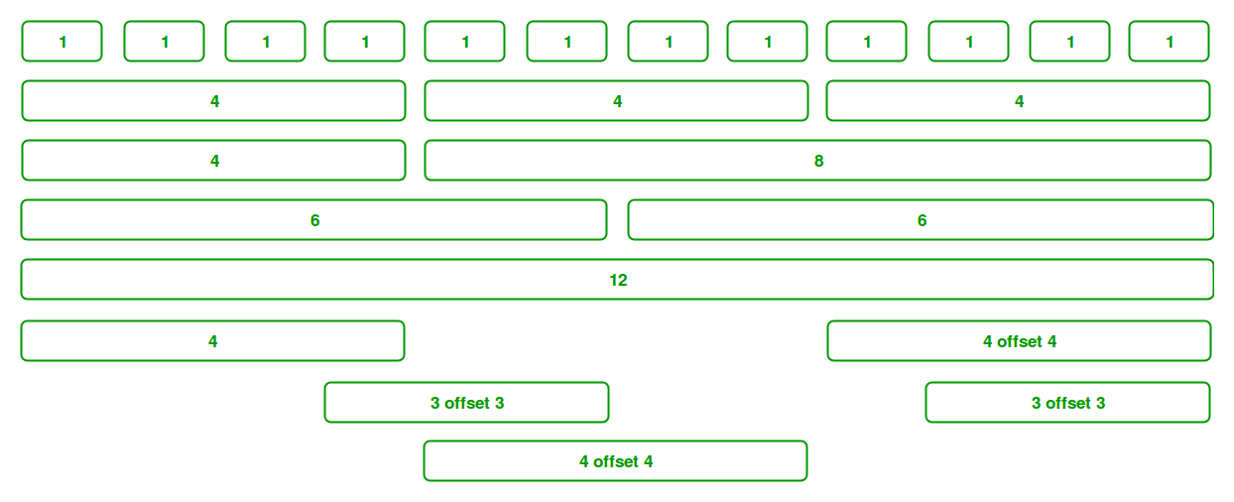](https://media.geeksforgeeks.org/wp-content/uploads/Bootstrap-part-2.png)

**5. What is the difference between Bootstrap 4 and Bootstrap 5**

**ans.**

| BASIS_Of | BOOTSTRAP 4 | BOOTSTRAP 5 |
| --- | --- | --- |
| **Grid System** | It has 5 tier (xs, sm, md, lg, xl). | It has 6 tier (xs, sm, md, lg, xl, xxl). |
| **Color** | It has limited colors. | Extra colors added with the looks, A card improved color palette. there are various shades available to choose. |
| **Jquery** | It has jquery and all related plugins. | Jquery is removed and switched to vanilla JS with some working plugins |
| **Internet Explorer** | Bootstrap 4 supports both IE 10 and 11. | Bootstrap 5 doesn’t support IE 10 and 11. |
| **Form elements** | | Radio buttons, checkboxes have different look in different OS and browsers. The form uses whatever default browsers provide. | The look of form elements will not change, on different OS or browser. The forms can be customized and form controls can be added, they would not depend on browser. |
| **Utilities API** | We cannot modify utilities in bootstrap 4 | Bootstrap 5 gave freedom to modify and also create our own utility |
| **Gutter** | We use .glutter with fontsize in px | We use .g* with fontsize in rem |
| **Vertical Classes** | Columns can be positioned relative | Columns cannot be positioned relative |
| **Bootstrap Icons** | Bootstrap 4 doesn’t have its own SVG icons, we have to use font-awesome for icons. | Bootstrap 5 have its own SVG icons |
| **Jumbotron** | It supports. | It doesn’t support jumbotron. |
| **Card deck** | The card deck is used to create a set of cards with equal width and height. | Card deck class in removed in bootstrap |
| **Navbar** | We have inline-block property and we will get white dropdown as default for dropdown-menu-dark class. | Inline-block property is removed and we will get black dropdown as default for dropdown-menu-dark class. |
| **Static Site Generator** | Bootstrap 4 uses Jekyll software. | Bootstrap 5 uses Hugo software as it is fast static site generator. |
| **flexbox grid** | this makes easier to implement vertical designs, and the columns and rows can easily be implemented. the classes justify-center-content can directly be used to align according to the requirement. | advanced grid system is made available , also columns don’t have relative positions. |
| **RTL Support** | It does not enable RTL(Right to Left) switching. | It enables RTL(Right to Left) switching. |
| **Offcanvas Component** | It does not support Offcanvas Component. | It supports Offcanvas Component(that is it is available now). |

**6. What is a Button Group, and what is the class for a basic Button Group?**

**ans.**

“Button Groups” in Bootstrap is a class of name “btn-group” which is used to create series of buttons in groups (without spaces) vertically or horizontally.

This is the basic syntax of the button group class where each button has its own class of “btn”.

<div class="btn-group">

<button type="button" class="btn">Click</button>

</div>

example:

<https://github.com/chandaniacharya/Assignments/blob/main/BS%20assignment%20practicles/buttun%20group.html>

**7.How can you use Bootstrap to make thumbnails?**

**ans.**

[Bootstrap](https://www.geeksforgeeks.org/bootstrap-tutorials/)helps web developers to create thumbnails that are used to show,linked images in grids with the pre-defined classes which help to reduce codes length.

Thumbnails are created to provide a quick preview of images with small images.

**Thumbnail Image:**A thumbnail is a small image that represents a larger image. Bootstrap has an easy way to do this with thumbnails. Bootstrap’s *.thumbnail*class is used to show linked images in grids ([grid system](https://www.geeksforgeeks.org/bootstrap-4-grid-system/)), a thumbnail is created using class *.thumbnail* within the element [<a>](https://www.geeksforgeeks.org/html-a-tag/#:~:text=HTML%20Tag,-Difficulty%20Level%20%3A%20Basic&text=The%20tag%20(anchor,as%20its%20%E2%80%9Chref%E2%80%9D%20value.).  The class *.col-sm-\**and *.col-md-\** (where * represent number ), it is used to create grids of the images.

example:

<https://github.com/chandaniacharya/Assignments/blob/main/BS%20assignment%20practicles/thumbnail.html>

**9. In Bootstrap 4, what is flexbox?**

**ans.**

The **Flexible Box Layout Module** in bootstrap is used for designing the flexible and responsive layout structure. It is used in Bootstrap 4.

* The ***d-flex*** class is used to create a simple flexbox container

**Syntax:**

<div class="d-flex p-2"></div>

* The ***d-inline-flex*** class is used to create an inline flexbox container

**Syntax:**

<div class="d-inline-flex p-2"></div>

* ***.d-flex* and *.d-inline-flex*** can be used for all breakpoints(sm, md, lg, xl) like .d-sm-flex, .d-sm-inline-flex, etc.

**Syntax:**

<div class="d-sm-flex p-2"></div>

<div class="d-sm-inline-flex p-2"></div>

**example:**

<https://github.com/chandaniacharya/Assignments/blob/main/BS%20assignment%20practicles/BS4%20flexbox.html>

**10. How can one create an alert in Bootstrap?**

**ans.**

Before or after performing an action, we frequently encounter specific notifications on some websites. These alert messages are highlighted text that should be taken into account when executing a task. Using preset classes in Bootstrap, these alert messages can be displayed on the website.

**Example :**In this example, we will use the warning alerts using the button click. When the user clicks the button, a warning alert will be generated.

<https://github.com/chandaniacharya/Assignments/blob/main/BS%20assignment%20practicles/alert%20in%20BS.html>

**11. What is a bootstrap card and how would you create one?**

**ans.**

**example:**

<https://github.com/chandaniacharya/Assignments/blob/main/BS%20assignment%20practicles/card%20inBS.html>

## **thank you**